AJAX

🌐 What is AJAX?
# Source: AI Source: Provided by: [Data Path: Persons Table -> ID Column: 1, Name_En Column: Motasem Essam] -> From: [Chatgpt (GPT‑5 Mini)] on [1/26/2026]
AJAX stands for Asynchronous JavaScript and XML.
It’s not a language — it’s a technique used in web development to send and receive data from a server asynchronously, without reloading the whole web page.

🧠 In Simple Terms:
# Source: AI Source: Provided by: [Data Path: Persons Table -> ID Column: 1, Name_En Column: Motasem Essam] -> From: [Chatgpt (GPT‑5 Mini)] on [1/26/2026]
AJAX lets your web page update parts of itself without refreshing.
Example: When you search on Google and the results change instantly as you type — that’s AJAX.

🧱 AJAX = Combo of Technologies
# Source: AI Source: Provided by: [Data Path: Persons Table -> ID Column: 1, Name_En Column: Motasem Essam] -> From: [Chatgpt (GPT‑5 Mini)] on [1/26/2026]
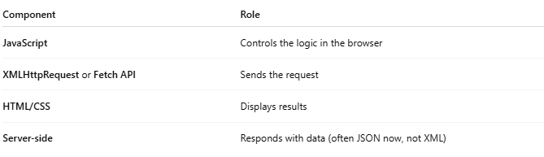
Component | Role
JavaScript | Controls the logic in the browser
XMLHttpRequest or Fetch API | Sends the request
HTML/CSS | Displays results
Server-side | Responds with data (often JSON now, not XML)
⚠️ Despite the name, AJAX mostly uses JSON, not XML, today.

🔄 How AJAX Works (Step by Step)
# Source: AI Source: Provided by: [Data Path: Persons Table -> ID Column: 1, Name_En Column: Motasem Essam] -> From: [Chatgpt (GPT‑5 Mini)] on [1/26/2026]
- User performs an action (e.g. clicks a button)
- JavaScript makes an AJAX request to the server
- Server processes it and returns data (JSON, text, etc.)
- JavaScript receives the response
- The web page updates a specific part (without a full reload)

✅ Real-World Example: Using fetch() (Modern AJAX)
# Source: AI Source: Provided by: [Data Path: Persons Table -> ID Column: 1, Name_En Column: Motasem Essam] -> From: [Chatgpt (GPT‑5 Mini)] on [1/26/2026]
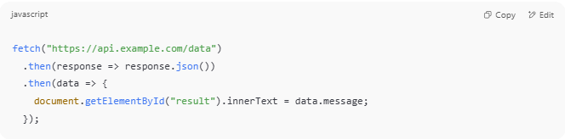
fetch("https://api.example.com/data")
.then(response => response.json())
.then(data => {
document.getElementById("result").innerText = data.message;
});

This will:
- Call an API
- Get data (e.g. { "message": "Hello" })
- Update the page with the result

🛠️ Classic AJAX (Using XMLHttpRequest)
# Source: AI Source: Provided by: [Data Path: Persons Table -> ID Column: 1, Name_En Column: Motasem Essam] -> From: [Chatgpt (GPT‑5 Mini)] on [1/26/2026]
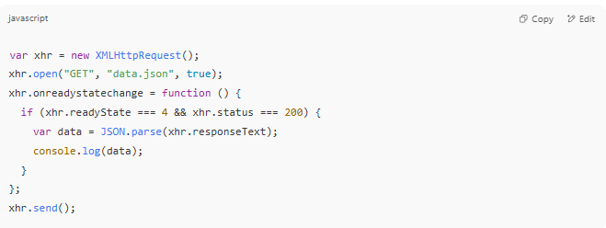
var xhr = new XMLHttpRequest();
xhr.open("GET", "data.json", true);
xhr.onreadystatechange = function () {
if (xhr.readyState === 4 && xhr.status === 200) {
var data = JSON.parse(xhr.responseText);
console.log(data);
}
};
xhr.send();

🧬 Data Formats Used with AJAX
# Source: AI Source: Provided by: [Data Path: Persons Table -> ID Column: 1, Name_En Column: Motasem Essam] -> From: [Chatgpt (GPT‑5 Mini)] on [1/26/2026]
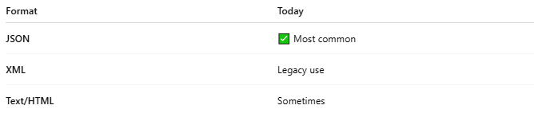
Format | Today
JSON | ✅ Most common
XML | Legacy use
Text/HTML | Sometimes

💡 Where is AJAX Used?
# Source: AI Source: Provided by: [Data Path: Persons Table -> ID Column: 1, Name_En Column: Motasem Essam] -> From: [Chatgpt (GPT‑5 Mini)] on [1/26/2026]
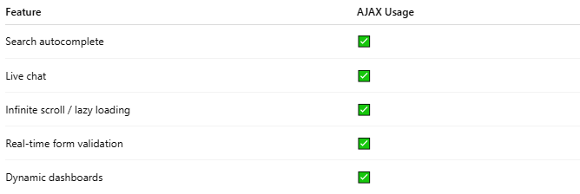
Feature | AJAX Usage
Search autocomplete | ✅
Live chat | ✅
Infinite scroll / lazy loading | ✅
Real-time form validation | ✅
Dynamic dashboards | ✅

📌 Summary
# Source: AI Source: Provided by: [Data Path: Persons Table -> ID Column: 1, Name_En Column: Motasem Essam] -> From: [Chatgpt (GPT‑5 Mini)] on [1/26/2026]
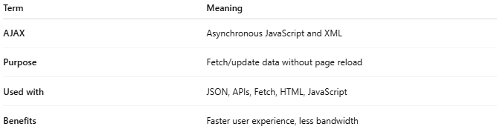
Term | Meaning
AJAX | Asynchronous JavaScript and XML
Purpose | Fetch/update data without page reload
Used with | JSON, APIs, Fetch, HTML, JavaScript
Benefits | Faster user experience, less bandwidth

